GANTT CHART for PROJECT WORK

Title:

Duration: 6 Months

|  |  |  |  |  |  |
| --- | --- | --- | --- | --- | --- |
| S.N | ACTIVITY | START DATE | END DATE | TIME | REMARKS |
|  |  |  |  |  |  |
| 1 | Title Defense |  |  |  |  |
| 2 | Proposal Defense |  |  |  |  |
| 3 | Introduction |  |  |  |  |
| 4 | Background |  |  |  |  |
| 5 | Literature Review |  |  |  |  |
| 6 | Instruments and Tools Test |  |  |  |  |
| 7 | Data Collection |  |  |  |  |
| 8 | Analysis and Comparison |  |  |  |  |
| 9 | Development |  |  |  |  |
| 10 | Test and Feedback |  |  |  |  |
| 11 | Draft Submission | August 18th 2021 |  |  |  |
| 12 | Review and Feedback | August 20th 2021 |  |  |  |
| 13 | Final Project Submission | September 17th 2021 |  |  |  |
| 14 | VIVA | September 24th 2021 |  |  |  |
| 15 | Report Binding | September 30th 2021 |  |  |  |

Department of IT

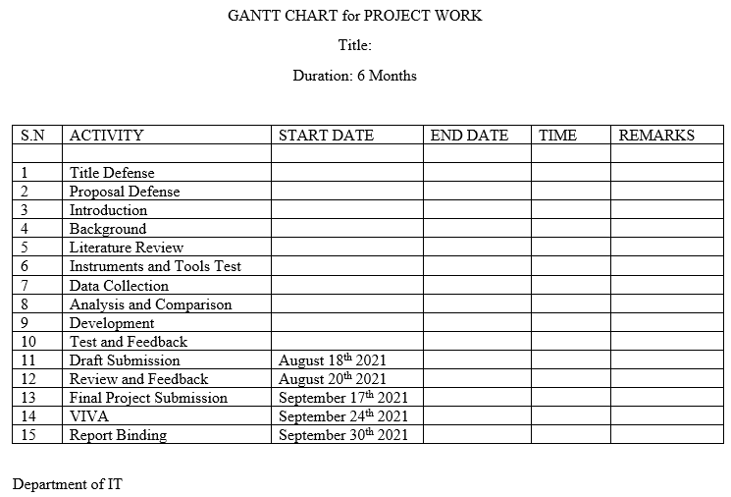

Title of the Proposal

The title of the proposal should be precise, reflecting the objective of the research work.

Table of Contents (Write according to the previous instructions)

|  |  |  |
| --- | --- | --- |
| S.No. | Chapters | Page no. |
| 1 | Introduction |  |
| 2 | Literature Review |  |
| 3 | Significance of Study |  |
| 4 | Scope of Study |  |
| 5 | Objective of Study |  |
| 6 | Research Methodology |  |
| 7 | Gantt chart |  |
| 8 | Bibliography |  |

INTRODUCTION:

Introduction to your project.

REVIEW OF LITERATURE

Review of the literature should be correlated with the significance of the study.

SIGNIFICANCE OF STUDY

Why this research required? What additional information will be gathered to support social or scientific world.

SCOPE OF STUDY

Need to describe the scope of the study.

OBJECTIVE OF THE STUDY

Aim of the study and principal objectives

You should provide a detailed account of the background to your research and the ways in which it will make an original contribution to knowledge in its specified field of study.

MOTIVATION

Why you are motivated to do this project

PROPOSED METHODOLOGY

This section should include a clear description of the techniques/methods will be adopted to accomplish the research work.

This section must reflect:

|  |
| --- |
| Research Design and Procedure |
| Operational Framework |
| Subjects or Data Sources |
| Instrumentation and Data Analysis |
| Assumptions and Limitations |

GANTT CHART

Gantt chart of the overall research plan

Research planning and schedule indicates progress monitoring deadlines and anticipated achievements or milestones such as completion of data collection, conference presentations, publication of articles or the proposed submission of your draft or final thesis.

Table Research planning and schedule (Gantt Chart)

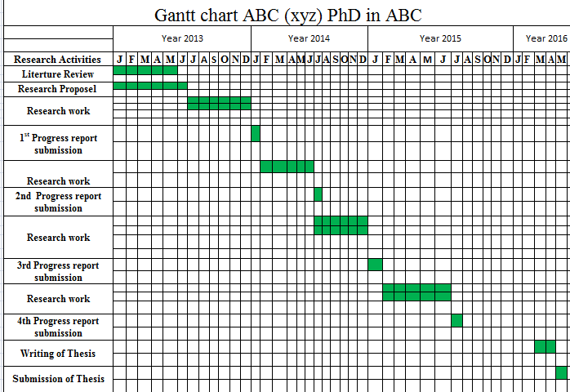

Development

Development Test Cases

Analysis and Comparison

Conclusion

Conclusion of your project

Future Expansion

What you can do and what you intend to do in your future with this project

Bibliography

Please provide the literature references supporting the research proposal. Please use APA or any standard referencing styled to cite the references.

References

References should be Harvard University standard

Annex

User Manual